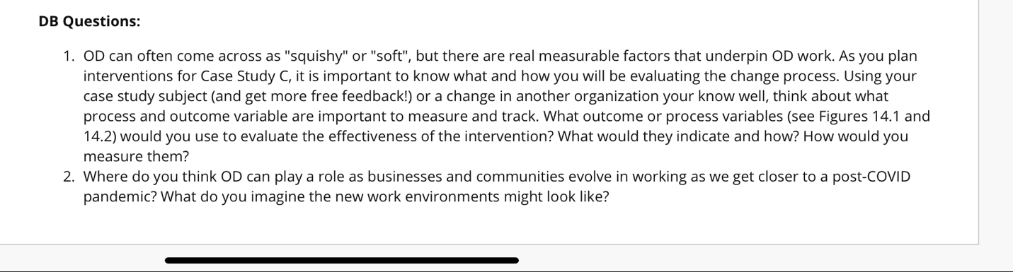

Case Study C Draft
Scope & Background.
The client is requesting help in changing their model from a functional model to a full client management services model. This model requires more teamwork. She is looking for more satisfied internal clients and fewer complaints while using less resources more Efficiently.
Old Model- The following people report to Susan McNulty:
Paula Washington, Recruiting. Recruiters report to Paula.
Linda Andrews, Compensation or Benefits. Comp specialists report to Linda.
Steven Peters, Employee Relations. ER Specialists report to Steven.
Matthew Williams, OD/Change Management. OD Consultants report to Matthew.
Tom Neill, EEOC or AA. Specialists report to Tom.
New Model-The following people report to Susan McNulty
Paula Washington, HR support, sales and marketing. A support team reports to Paula.
Linda Andrews, HR support, Software engineering. A support team reports to Linda.
Matthew Williams, HR support, distribution. A support team reports to Matthew.
Tom Neill, HR support and EEOC, corporate functions. A support team, data analysts, report to Tom.
concerns and issues: The main problem is the HR managers having a large workload because of the formal centralized HR approach which doesn’t take into account the customer centered approach. Employees who are unsatisfied with HR are considered internal customers or customers in this case. The recruiting/hiring/training process is a meticulous and timely process, which needs to be shortened.
Findings:-
The “internal” customers have not been happy with the current HR service.
The company has issues recruiting new individuals and turnover makes it even more difficult.
There isn’t just one individual for the HR portion. Management is often having to go through multiple people, which is causing frustration.
If the internal customers and employees aren’t happy with the current HR service, then this could lead to a higher turnover rate.
The company has issues recruiting new employees because of the internal factors lacking a prominent HR department, this could really pose a threat to the hiring rate and make the hiring process that much slower. This will eventually hurt the company as a whole. If the turnover ratio is higher than the hiring ratio, then the company is going to plummet.
Management having to go through different departments to talk with different managers during the hiring process can be tiresome and frustrating. This problem can lead to different ideas and answers being told to the individual seeking the information which could ultimately cause confusion and make the process even more difficult.

Look at both presenting problems and possible underlying and/or root causes. Considering multiple causes is encouraged.
There currently isn’t a direct HR department within this company which is causing lots of unnecessary running around. Based on the chart that Susan provided on page 367, it looks like she should isolate employees to only handle HR-related problems and tasks. Then, she should hire new qualified individuals to replace those whom she moved to HR. Or, she could keep those individuals where they are at in management, and hire a completely new set of individuals for HR purposes. Because there isn’t just one department directed towards HR, these issues are being caused because there are too many focal points that managers have to focus on instead of just one.

Discussion:-
Present a summary of each problem you have identified.
The overall problem is that the internal client managers aren’t satisfied with the current HR service because of their issues with their recruiting procedure and turn around. They need to recruit 200 new positions a year and every recruiter is handling 24 positions at any point in time. A manager will need to hire someone and then call for someone in Paula’s organization to have the position available. After reaching out to Paula’s organization, the manager will need to talk to someone on Linda’s team to figure out the compensation for the position. It is a lot of steps for a routine that can be done in a much more organized and efficient way.

Present plausible solutions for each of the problems, keeping in mind that each problem will likely have more than one possible solution.
A plausible solution is to have recruiters understand the situation of the positions. Then to bring up the turnover rate towards the company since it has a direct impact on their roles and multiple other positions. The best solution would have someone on each team take up the role to provide information about the position availability, compensation amount, and employee relations.

Provide the pros and cons of each solution in a way that is practical.
The act of bringing forward the need for change about the turnover requires a lot of study and long-term change. It will be costly in money and time to move this solution as a priority. This issue should be brought up sooner to implement small changes that are more manageable.
The pro of having someone take on the role to provide detailed information is that it is less phone calls with questions that will be asked multiple times. This allows the recruiter to have all present information in front of them. The con of this solution is that the person who may need to take up this role has to be multiple people like Paula, Linda, and Steven.

Recommendations.
Customer Satisfaction:Customer satisfaction is low and this is a major issue. In order to switch focus to a more client centric business model, all associates should be aware of the company priority. This can be achieved through proper training and knowledge transfer down the hierarchy. Consistent feedback from both the clients and the associates is key in this process. The client feedback will be used to decide strategy changes that will enhance the customer experience, while the employee feedback will be used to make process changes that will make the service streamlined.
Efficiency: The rate at which employees are being recruited is sluggish. This needs to be cut down in half. First, the expectation needs to be set with recruiters on the time as well as the quality of recruits. This expectation will determine their performance. Second, they need the resources that will help them to drive this change. The resources will include leads as well as internal support from other HR representatives.
Team Building:This brings us to the next issue that needs to be resolved. The company is initiating new changes to the HR structure, which means that the employees are going to be working with new team members that they have not worked with before. This will require coordination and team building. Team building efforts could include team members having to spend time outside of work. For example, happy hours, corporate events, volunteering opportunities, etc.
Intervention Implementation Ideas
There should be a set procedure for the way recruiters are hiring. Paula, Linda, and Steven (or their most competent team members) should handle a form that lists the details and job descriptions to help with the process of recruiting. First, the recruiters need to take into account all the information needed from each team and send them out individually. The most accountable people in each team would fill out the document with complete details to avoid extra phone calls and delaying the hiring process. With the extra time, HR would be able to develop more time into its current employees.

This may be costly in the sense of having more paperwork filed but it is less phone calls. This also allows less of a run around and promotes a structure in the organization. This implementation would take less than continuing with the current process. It would potentially save money and promote a smooth productive work environment

